

**ENGR1025U: DESIGN PROJECT TECHNICAL REPORT**

**BetterLift**

**Executive Summary**

As a collective society, building has always been a fundamental aspect of our civilization. From the pyramids of Egypt to everyday homes, we have always been building high objects. However, to build these structures, traditional building methods would often require large teams of workers to hoist objects up or resort to unsafe methods to reach great heights. In recent years, there has been a shift to developing aids that make construction more efficient and safe. The introduction of scissor lift and other lift devices have revolutionized the way we approach building, allowing us to reach heights and access hard to reach areas with ease.

Scissor lifts are particularly useful for granting temporary access to elevated areas for both equipment and individuals. The linked folding supports that are arranged in a scissor-like pattern allow for smooth and stable vertical movement.

Our company is dedicated to manufacturing and producing the utmost highest quality scissor lifts. We prioritize designing a lift that is safe, efficient,and caters to the needs of a diverse range of users. Therefore, we are showcasing our new design on the scissor lift, HeavyLifts own BeyondX5. Our lift promises to surpass market expectations and set a new standard in the lifting industry.

With our lift, users can expect a safer, more efficient experience that can help maximize their productivity and minimize the risk associated with traditional construction.BeyondX5, has been designed with safety and efficiency in mind. With its sturdy construction and reliable hydraulic system, users can feel confident that they are operating a lift that meets all necessary safety standards. Additionally, BeyondX5 offers a number of features designed to improve efficiency, including easy-to-use controls and a compact design that allows for greater maneuverability in tight spaces. By minimizing the risk associated with traditional construction methods and maximizing productivity, our lift offers users a significant competitive advantage.

In order to reach this stage, we went through a lengthy process to find the correct lift idea with the best materials to ensure safety, user experience, and cost-friendly lift. After the thorough process, we believe we came up with a lift that achieves the goals set in places.

To conclude, the evolution of technology has paved the way for a safer, more efficient method of construction. Our company is proud to contribute to this progression by designing a high-quality lift, BeyondX5, that will meet the needs of a diverse range of users.

**Table of Contents**

Title page……………………………………………………………………………I

Uniform Team Identification Page………………………………………………….II

Executive summary…………………………………………………………………III

Mission statement…………………………………………………………………...1

Customer needs assessment…………………………………………………………2

Major design specifications……………………………………………………….…3

Sketches…………………………………………………………………………...…4

Concept selection process………………………………………………………...….9

Detail description………………………………………………………….…………11

Gantt Chart…………………………………………………………………………. 17

Conclusions…………………………………………………………………………18

Acknowledgement…………………………………………………………………..18

Reference………………………………………………………………………...….19

Script…………………………………………………………………………………20

**Mission Statement**

BetterLift’s objective is to lead the way in creating, developing, and manufacturing the most advanced scissor lifts in the industry. We achieve this by focusing on safe and efficient design that caters to the needs of a diverse range of users, whether they require casual or heavy-duty usage. We prioritize the safety of our users while maintaining a focus on functionality and versatility, so that our scissor lifts can meet the demands of any task or project and set a new standard on what a scissor lift is.

We strive to give our customers the best of the best and with that promise, we have ensured to make the safest and most sound design possible that provides an optimal experience while using our scissor lift. With that, we are here to present to you BetterLift’s new design, BeyondX5.

Our mission is centered around creating, developing, and manufacturing scissor lifts to cater to a wide range of users. To do this, we are committed to setting a new standard by prioritizing safety, functionality, and versatility. We want to provide customers with the best possible experience to meet and exceed expectations with the product we offer.

We believe that safety is important and a crucial factor when designing lifts. We understand the importance of creating a safe product that provides customers with a peace of mind while operating. Our lifts are designed to ensure the safety of our users in every aspect possible. By using high-quality materials, latest technology, and innovative designs, we created a lift that is reliable, high-performing, cost-friendly and safe. We believe that our customers should have the best possible experience when using our products and knowing that they are safe and efficient.

In summary, our mission is to create, develop, and manufacture scissor lifts that cater to a wide range of users, while prioritizing safety, functionality, and versatility. Our commitment to excellence has led us to introduce our latest design, the BeyondX5, which upholds our innovation, safety, and excellence. We are confident that this new design will set a new standard in the industry and we are excited to show our customers what we have to offer.

**Customer Needs Assessment**

To manufacture a scissor lift, it is important to understand the needs of our customers to create a product that meets their requirements and specifications. This can be done by identifying the specific requirements and expectations of customers who are considering purchasing a lift. The key considerations in this assessment include height requirements, portability, load capacity, safety features, cost, and environmental impact.

Height requirements are important for customers to ensure that the lift they are buying can reach a desired height safely and effectively. Portability is also important to consider as it may be needed to transport the lift to different job sites or set in up tight places. Load capacity is also an important thing to consider as customers may require a lift that can handle specific types of equipment or materials.

Functionality is another essential aspect of our lift design. It is critical that the lift can reach a height of 14-18 feet and be able to withstand a load of up to 900 lbs for indoor usage. Safety is an essential concern for scissor lift customers and therefore, requires specific safety features such as emergency break, and fail-safes to prevent accidents.

Customers may be inclined to a more environmentally friendly option and therefore, it is important to consider materials used in the production of the lift, as well as the energy consumption required for its operations to ensure that the lift is as environmentally friendly as possible. We strive to use materials that are recyclable inorder to reduce the environmental impact of our production as well as reduce the overall cost to produce the lift and therefore, reduce the market cost.

Finally, cost is a significant factor in the success of our lift in the market. We aim to use cost-friendly materials to lower overall production cost and ensure that our product remains competitive in terms of pricing. By balancing cost with other design considerations, we aim to create a lift that is both affordable and effective.

In conclusion, understanding the specific needs of customers such as height requirements, portability, load capacity, safety feature, cost and environmental impact are essential in the design and manufacturing process. By meeting the needs of customers, we can produce a lift that satisfies our target market.

**List of Major Design Specifications**

Our team was able to identify several major design specifications for our final lift product. The specifications include assembly, portability, functionality, safety, environment impact, with cost

assembly and portability being key considerations for our lift design. We aim to create a product that can be quickly disassembled and assembled without any issues, with the goal of making it easy to transport and set up at different working sites. To achieve this, we will use lightweight materials that are able to be carried by two adult workers for indoor projects.

Functionality is another critical aspect of our design. We need to ensure that the lift can reach a height of 14-18 feet and be able to withstand a load of up to 900 lbs for indoor usage. We will incorporate safety features to ensure that the lift works safely, including a platform that prevents falls, back up safety functions such as backup brakes, and components that maintain stability on uneven surfaces.

Environmental impact is also an important consideration for our lift design. We want to make sure we select materials that can be easily recycled and replaced that do not have a significant environmental impact during production. Such materials include: Mold on rubber, plastic, and aluminum. By prioritizing sustainable materials, we hope to reduce the environmental footprint of our product. The inclusion of a power unit acts as a backup, in the case that the wiring were to fail. This acts as a failsafe to protect workers who may be suspended multiple feets in the air and ensure that the lift stays operational even without a current running through. The power unit is emphasized to be auxiliary to the lift, while the industrial plug remains its main source of power as we strive to reduce the impact that our machines have on the environment.

Lastly, cost is a significant factor in the success of our lift in the market. We want to make sure to use cost-friendly materials to lower overall production cost and ensure that our product remains competitive in terms of pricing. By balancing cost with other design considerations, we aim to create a lift that is both affordable and effective.

Overall, we want to commit to creating a lift that meets the highest standards of safety, functionality, and environmental sustainability while remaining cost-effective for our customers. With these design specifications in mind, we are able to create a lift that meets the needs of users or a variety of indoor settings.

**Sketches**

Concept one:

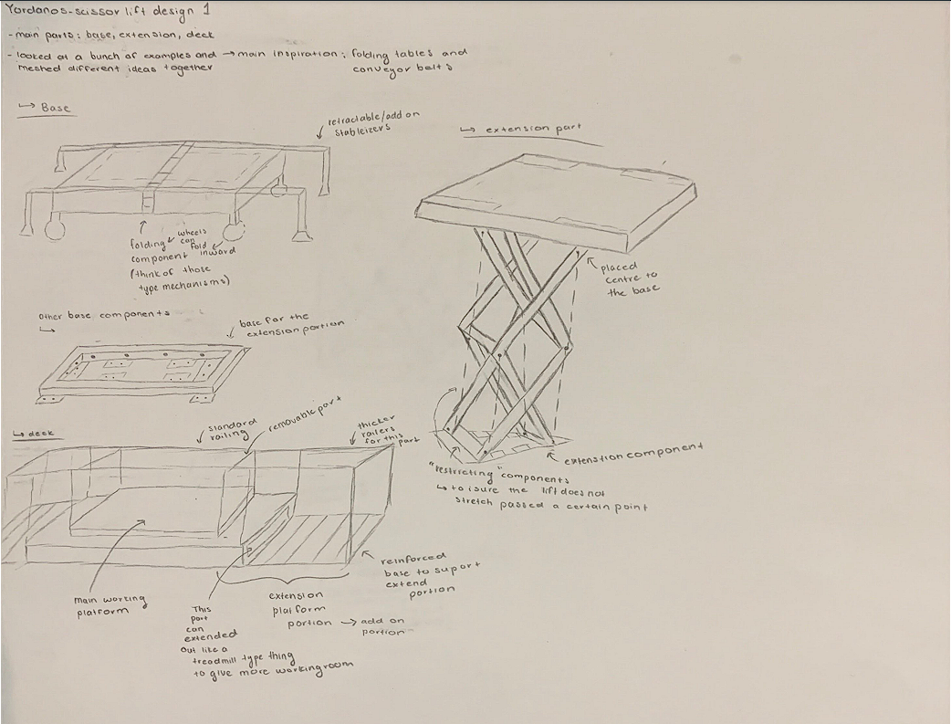

|  |  |
| --- | --- |
| **PROS** | **CONS** |
| Compact | Possibly not structurally sound |
| Easy to transport | Extension may cause machinery to tip |
| Large surface area to work on |  |

Concept two:

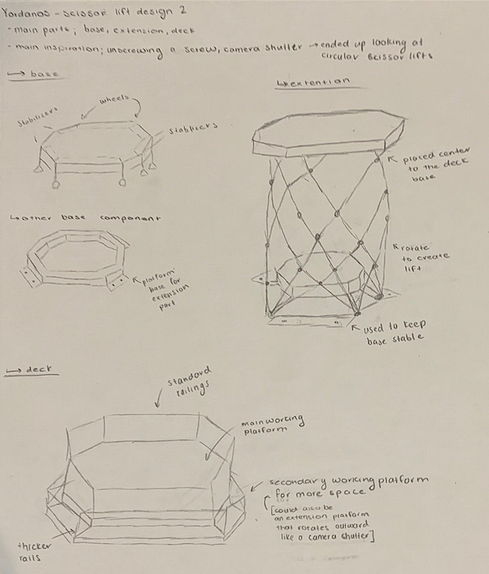

|  |  |
| --- | --- |
| **PROS** | **CONS** |
| Large work area | Not structurally sound |
| Rotating surface that allows for easy access | Extending platform complicates railing. |

Concept three:

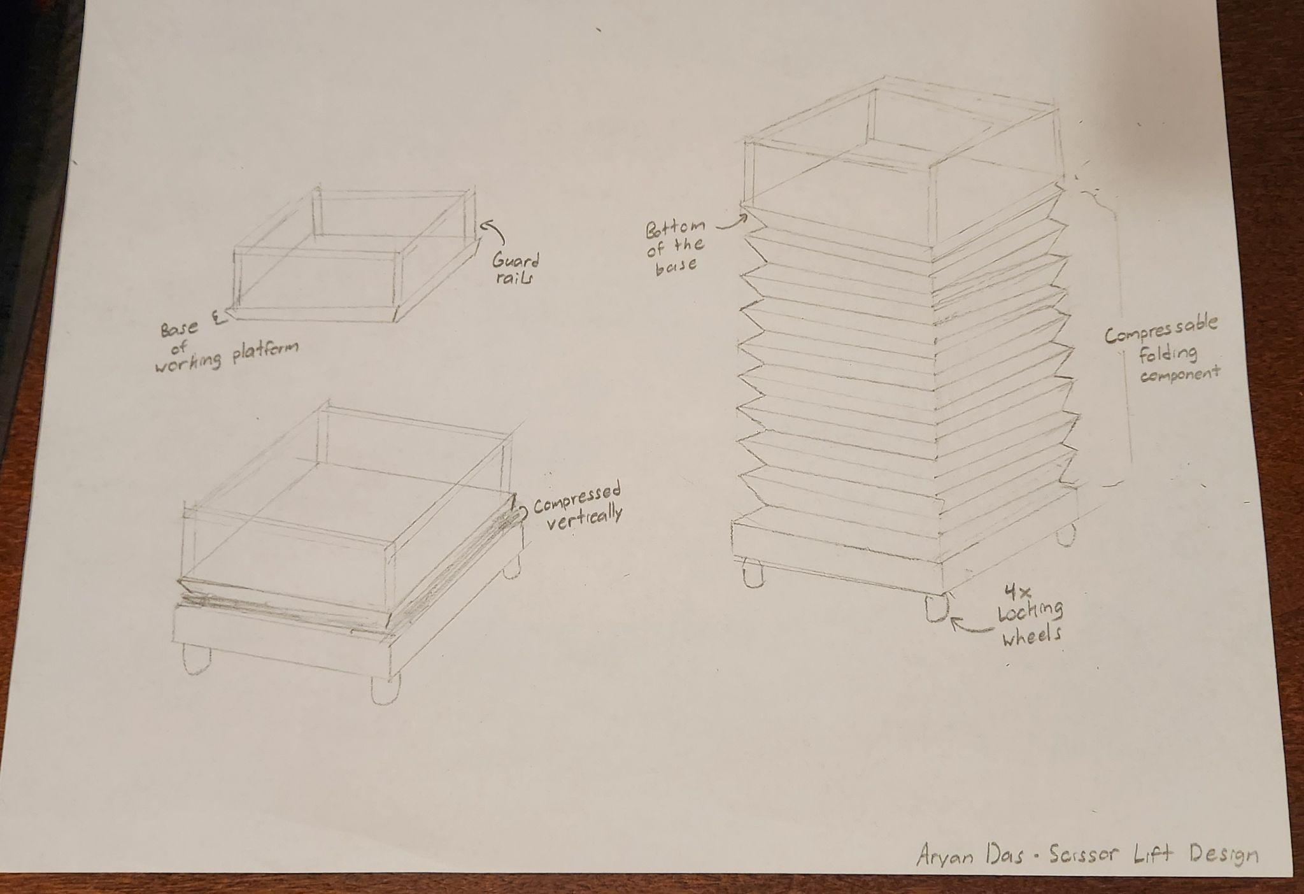

|  |  |
| --- | --- |
| **PROS** | **CONS** |
| Spacious | Rail opening poses a threat to safety |
| Safe | Pressure might dissipate over time; danger factor increases with time |
| Locking mechanism on wheels | Compression causes wear and tear in mechanism; components are not built to last long |

Concept four:

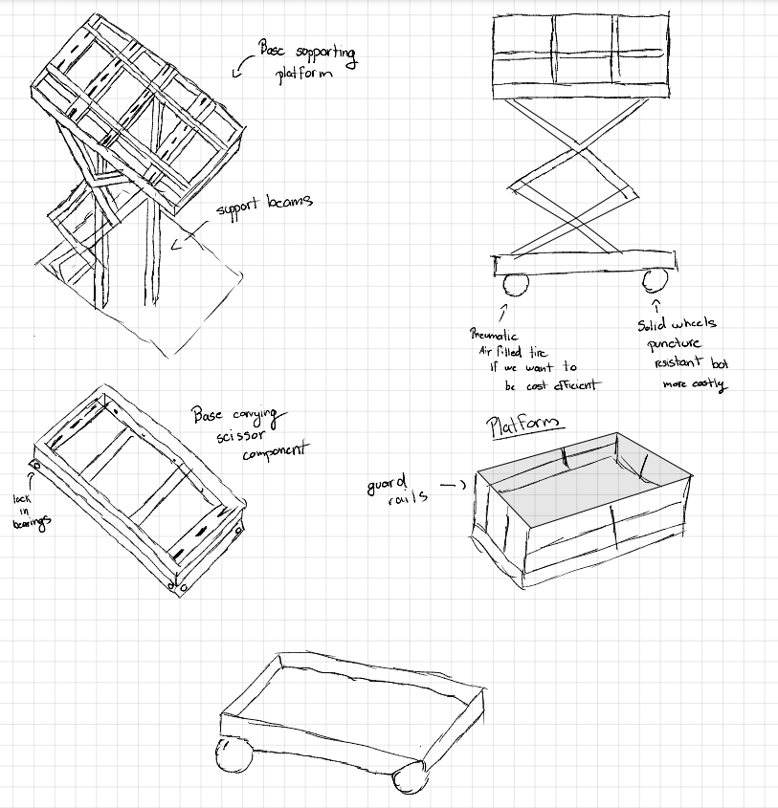

|  |  |
| --- | --- |
| **PROS** | **CONS** |
| Compact | Difficult to implement support beams with extending beams |
| Strong support beams | Base portion is undeveloped |
|  | Unoriginal idea with basic design |

Concept five: 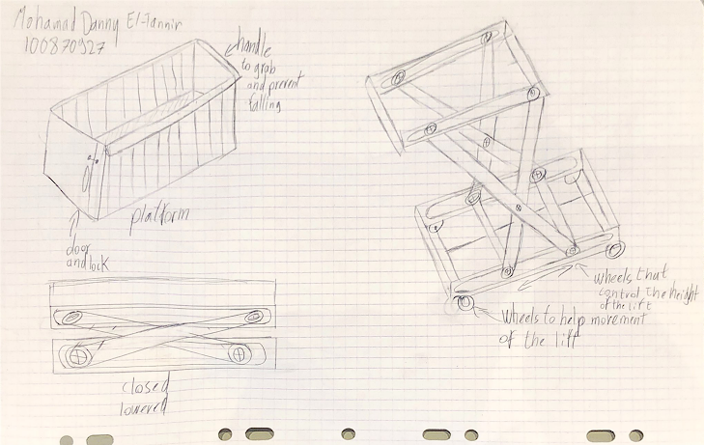

|  |  |
| --- | --- |
| **PROS** | **CONS** |
| Compact | No competitive edge (Basic idea) |
| Easy to transport |  |

Redesign sketches:

Concept six A)

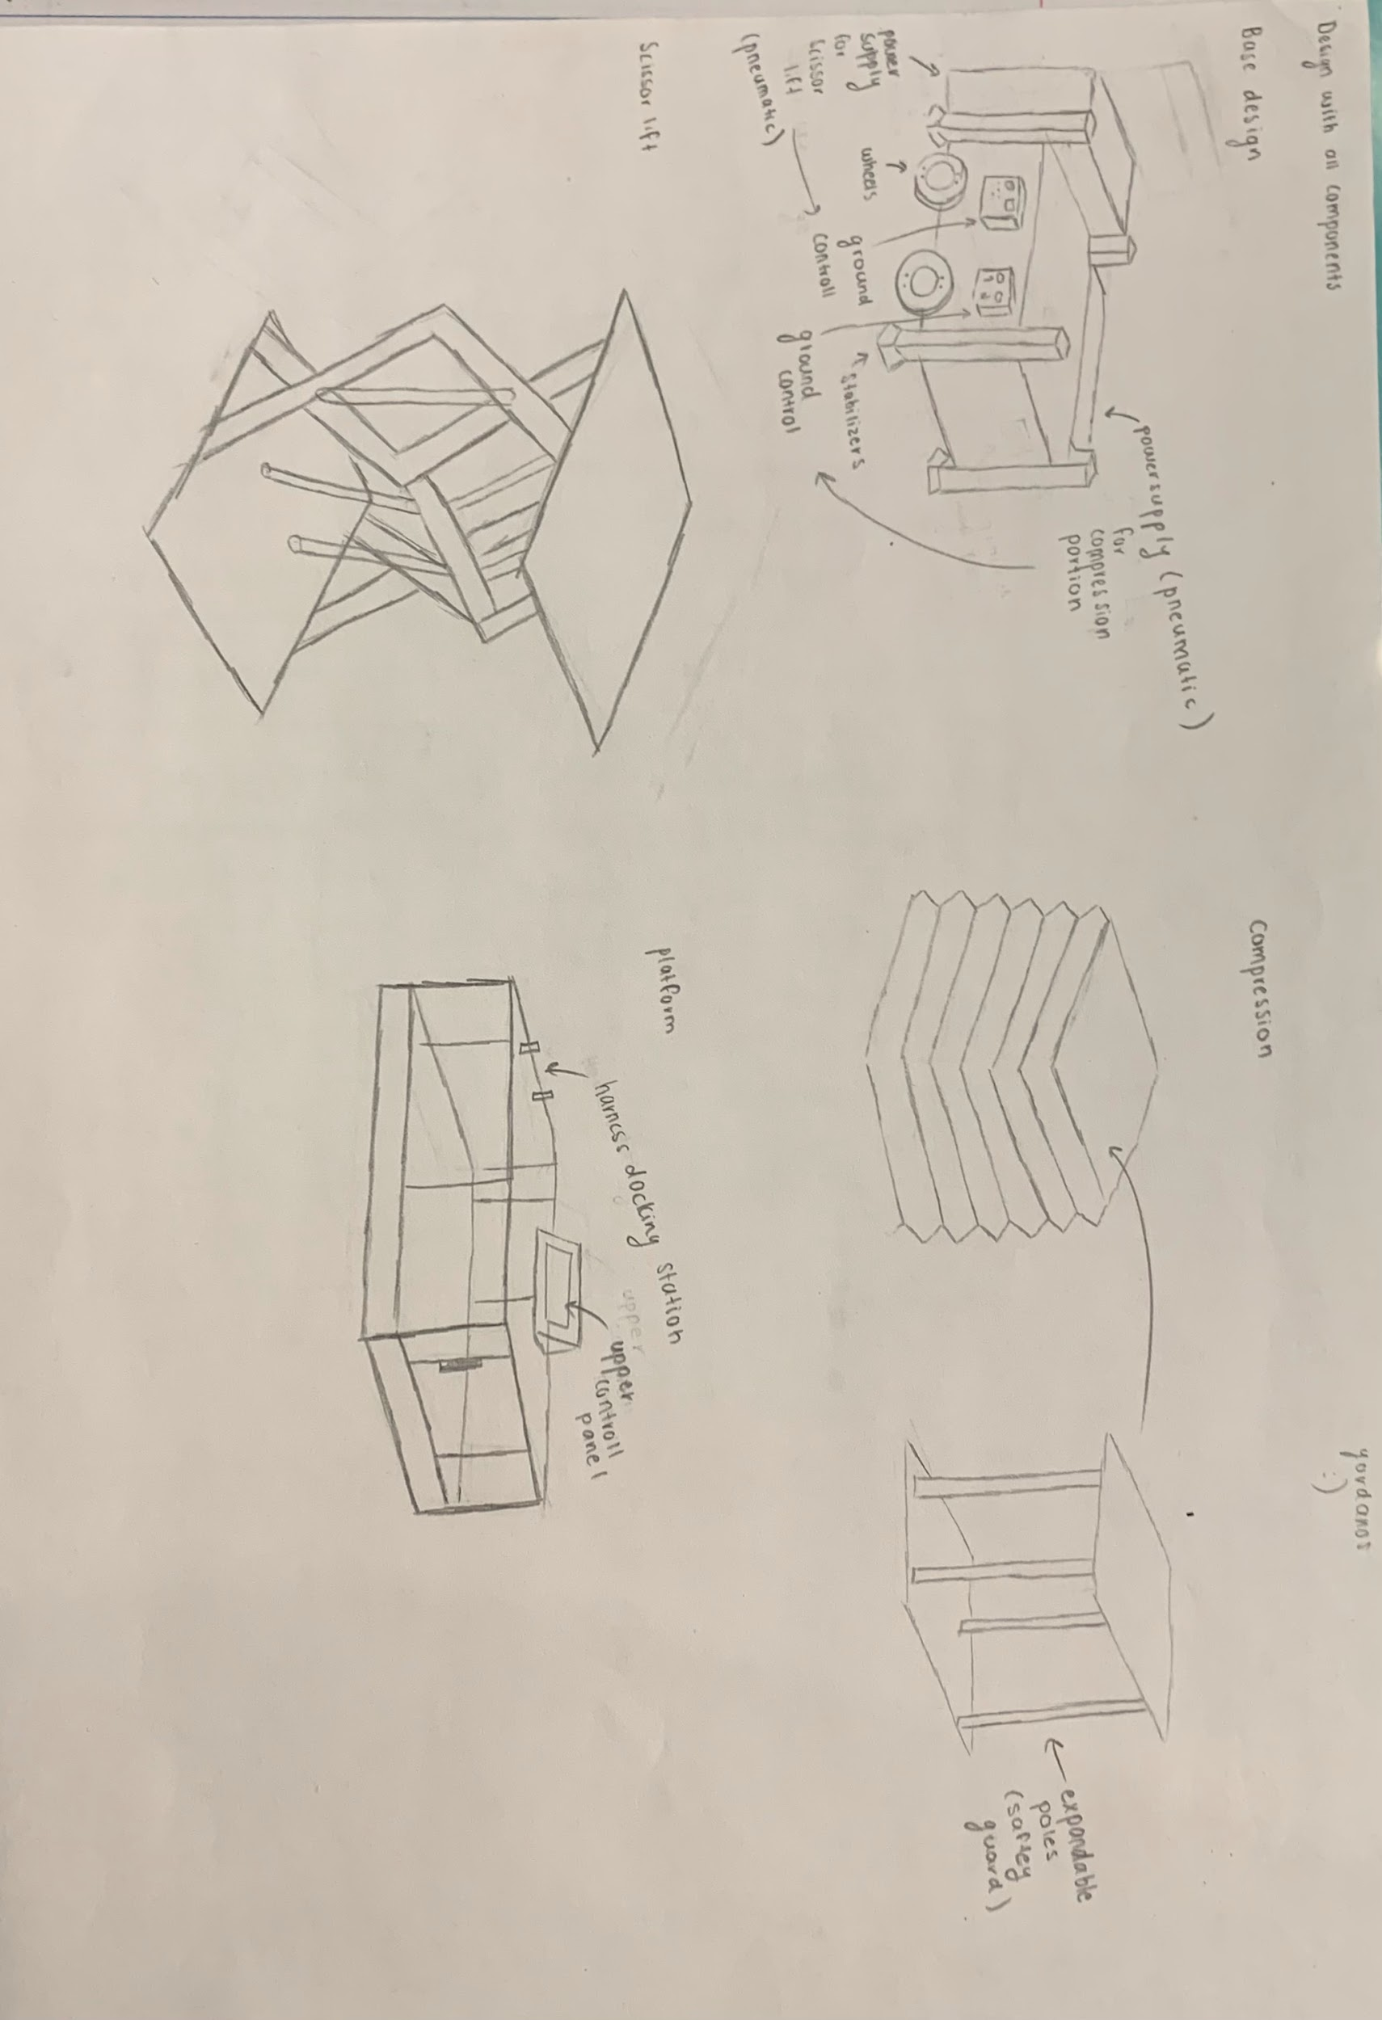

Concept six B: Final concept design

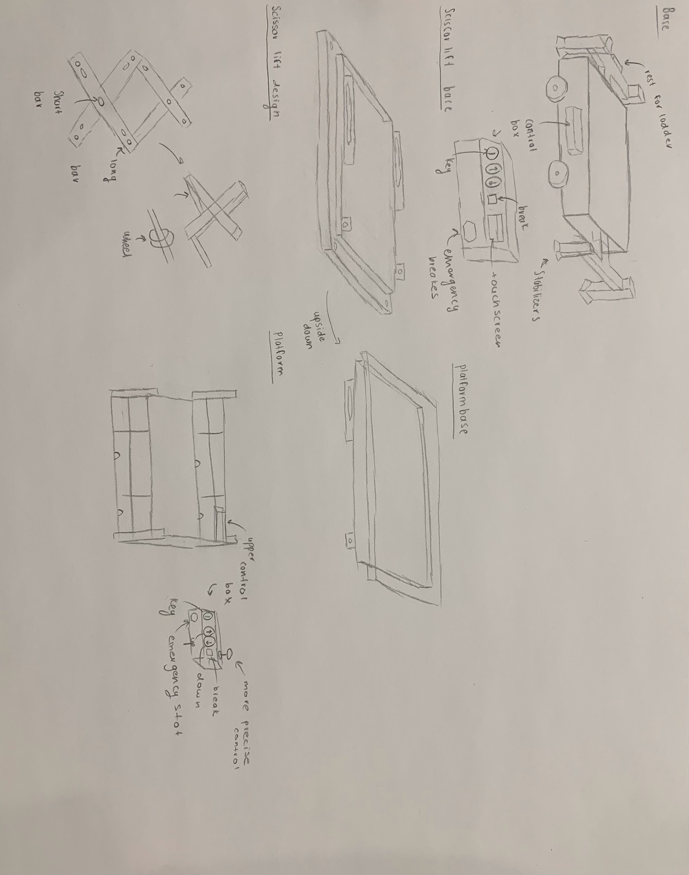

|  |  |
| --- | --- |
| **PROS** | **CONS** |
| Strong stabilizers | Large build due to extending stabilizers |
| Easy access due to ladder |  |
| Safest design with complete railing |  |

**Concept Selection Process**

To get to our final design, we went through an intense analysis of every concept we proposed. As a team, five main designs were pitched, each with components that would be beneficial to include as well as aspects that were not necessary or the best fit. After a thorough discussion,we arrived at a final product.

Our main criteria for evaluating the design included functionality, assembly, portability, safety, and materials. When looking at each design, we made sure to take note of parts that were assets, as well components that were unnecessary. As a result, our final product is a combination of various different elements from each of our 5 main designs.

For concept one, we emphasized its compact design, allowing for it to be able to get into those tight spaces when working on indoor construction. It is also easy to transport, making it easy to move from one place to the next without worrying too much about external and internal factors such as having to take the entire lift in one go instead of part by part. It also provides ample working space for easy usage and less concern about setup. While it had some great components, there were still some design issues. The main issue with this design pertained to safety concerns with the extension portion, as there is a chance of it not being able to support enough weight and tipping over. Another concern was cost because the lift has an extension portion both for the top platform and stabilizers, which could increase the production cost.

For concept two, we recognized that the idea provided lots of working space for individuals, and the design would be easy to rotate and lift up. However, we highlighted that the structure itself is purely hypothetical and may result in it being structurally unsound. The extending part of the platform is also inconvenient due to the railing.

For concept three, we noted that the design looked spacious for workers to work on and seemed safe as well as the locking component for the wheels being a good idea to include as a safety component. However, a major issue arose with the compression portion of this design. The main function behind this design was to use air pressure to fill the compression full of air to create the lifting mechanism. However, we noted that the air pressure may wear down after an extended period of time as well as the fact that the compression portion may not be stable for general use which could lead to safety hazards.We also noted that, since this lift is powered through air pressure, it would be pneumatic lift however, to be able to function this lift, we would require a huge reservoir of air pressure which posed an issue of where it could be stored. Another factor that posed a problem was that the material the compression would be made of. To find a material that would be able to compress similarly to that of an accordion as well as be able to withstand a large amount of load at any given time was nearly impossible. There was a suggestion to use integrated nanotechnology for the compression material however, to be able to do that would cost quite a bit as well as make it hard to replace if something were to happen. The last concern with this design was that the railings may pose a safety issue with that much open space. Items may be able to fall which poses a hazard for individuals on the ground level.

For concept four, we noted that the design looked stable as well as compact. We also liked the detailed description on the wheels as it provided us some insight on cost analysis later on in the project. However, we had one major critique which was that the support beams were placed in an unusual place; however, we did highlight that they were something that could potentially work.

For concept 5, we noted how the design was a solid design that was compact as well as easy to transport which is an asset for portability.

When it came down to finalizing the concept selection and narrowing down to one idea, there was a bit of back and forth. We initially set on concept 4 with some added mechanisms which can be seen in redesign 6a. We added a more indepth look at the base of the lift which included stabilizers as well as control box as well as a more indepth look at the platform which we also added a control box as well as more railings and a door. The major addition was with beams within the compression portion to provide stability as there was still uncertainty with whether or not the lift itself was a safe option.

However, even with the redesign of 6a, we highlighted how it was still very hard to find any sort of cost-friendly material that would be able to be used for the compression portion as well as the fact that 4 support beams may still not provide the necessary stability needed. Therefore, we scrapped that idea and opted to mix different parts from each design into one final design.

With that, our finalized design was 6b which includes the base design of 6a, the scissor lift design of concept 5, the platform design of concept 6a, and base for the extension design of 5 and 4. With that we built our lift on solid work and factoid in the necessary aspects such as dimension and material.

**Detailed Descriptions About Final Design**

|  |  |  |  |  |
| --- | --- | --- | --- | --- |
| Item. | Components | Description | Quantity | Cost approximation |
| 1 | Base | The lift’s foundation is provided by the base, which houses the 24VDC, 3kW power unit. Additionally, the base includes all the wiring required for the control boxes, as well as the wiring to the cylinder head and shaft which forms the root of the lifting mechanism. To achieve cost-efficient production, the base casing is made of lightweight hot-dipped galvanized steel sheets with mesh aluminum inside. The base also includes a component that securely holds the lower control box as support beams that stabilize the lift. | 1 | Hot-dipped galvanized steel →$1.76 $/ft^2  Power unit→ $130-$1000 |
| 2 | Scissor Lift wheel base | The scissor lift’s smooth movement is enabled by the wheel base, which acts as the rolling mechanism on both the base and platform. To achieve a smoother lift, the wheels are made of polyvinyl chloride (PVC or Vinyl), while the axle bar is created from lightweight aluminum, ensuring a cost-friendly production without sacrificing performance. | 2 | Aluminum rod→ $1-20 depending on the length required  PVC wheel→ $16-50 |
| 3 | Lift legs/beams | The lift beams (or legs) are what will move the scissor lift upwards and what produce the functionality of it. These beams are made of a steel alloy of medium carbon steel which have a high tolerances without cracking or breaking under high-stress levels and are light weight as well as high tension resistance when carrying individuals as well as and other loads on the platform | 16 | Aluminum rod→ $1-20 depending on the length |
| 4 | Scissor component base | The component base acts as a link between the platform and base as well as provides the rolling mechanism to move the lift upward. This component locks in the scissor lift mechanism to the base and platform to ensure stable connection and acts as a frame for the lift. It is made of a cold-formed steel as it is lightweight and strong | 2 | cold-formed steel → $50-400 (depending on the square inch) |
| 5 | Wheels | The wheels provide the ability to move the lift from place to place. To ensure safe travel, they are made up of mold on rubber wheels which are designed for heavy-duty applications and have a high load capacity. As well as provide good traction on indoor surfaces. | 4 | mold on rubber wheels→ $25-180 (depending on size) |
| 6 | Base axel | The axel connects the scissor lift and wheels together to produce functioning mobility. This part is made up of aluminum rods. | 1 | Aluminum rod→ $1-20 depending on the length |
| 7 | Scissor Base bar | The base bar is the rod that connects the scissor lift to the scissor components base and ensures stable connection through the extruded portion of the component base that allows for the rod to sit tight and snug. This rod is also located on the top component base and functions the same way. Both are made up of aluminum rods. | 2 | Aluminum rod→ $1-20 depending on the length |
| 8 | Scissor Base bolt | The bolts act as fasteners between the component base and the actual base of the scissor lift. These are removed to make the lift easy to disassemble however, when in use, they provide a strong and tight connection. These are made up of grade 410 stainless steel as it possesses high strength and hardness coupled with good corrosion resistance | 4 | Grade 410 stainless steel bolt → $20 to 180 (depends on the size |
| 9 | Long bar | The long bar is what is used to connect both sides of the scissor lift legs/beams together. The bar is made of up aluminum rods | 6 | Aluminum rod→ $1-20 depending on the length |
| 10 | Short bar | The short bar is what connects the lift beams to the other lift beam in a scissor like style. The bar is made of the aluminum rod | 8 | Aluminum rod→ $1-20 depending on the length |
| 11 | Cylinder head | The cylinder head is part of the function that will move the lift either upwards or downwards. It will either extend outwards to go up or retract inwards to go back down. This is paired with the cylinder shaft to produce a full function lifting mechanism. This will be made up of an aluminum rod and aluminum block that will be manufactured into its designated shape | 1 | Aluminum rod→ $1-20 depending on the length  Aluminum block → $1-35 |
| 12 | Cylinder shaft | The cylinder shaft is the second part of the function that will move the lift either upwards or downwards. The cylinder head will either extend outwards or retract inwards to the shaft. This will also be made up of an aluminum rod and aluminum block that will be manufactured into its designated shape | 1 | Aluminum rod→ $1-20 depending on the length  Aluminum block → $1-35 |
| 13 | Lower control box | The lower control box allows for general control of the lift. It requires a key to be able to start the entire lift to ensure the right individuals are using the lift. It contains 3 main buttons. A regular brake button to stop the scissor lift when needed, and then both an up and down button to control the direction of the lift. The control box also has an emergency break that can be used whenever the regular breaks are not functioning. The last component is a screen. | 1 | Plastic buttons (x4)→$30-50 each  Ignition key Key(x1)→ $30-40  Steel sheet→ $20-40 depending on size |
| 14 | Stabilizers | The stabilizers act as added support measures to keep the platform in place as well as stable for individuals and objects on the lift. The outer box serves as the container which is made up of polyvinyl chloride (PVC), the functional part of the stabilizers are made of fiberglass | 4 | PVC sheets for casing → $20-100 |
| 15 | Stabilizer support | These are where the stabilizers attach to. They are attached to the platform and extended outwards in ‘T' like shape to allow the stabilizers to attach to the ends. These are built out of steel sheets. | 2 | Steel sheet→ $20-40 depending on size |
| 16 | Platform | This is the working area for the individuals as well as where any loads will be located. The platform has added guard rails that will act as a safety measure to ensure nothing slips out and falls. The platform also contains a latch for the door to seacure on, an upper control box, and harness cliping areas located near the edge of the platform. The platform is made from an aluminum mesh on the inside to provide a lightweight, carryable platform and it covered with thin aluminum sheets to remain as lightweight as possible | 1 | Aluminum sheets→  $2-50  Aluminum mesh→ $2-60 |
| 17 | Platform door | The platform door rotates outwards to allow individuals and objects to get on and off. The door also has a latching component to the platform to ensure that if someone were to accidentally push on it, it would not just open and cause the person to fall. The platform is made from an aluminum mesh on the inside to provide a lightweight, carryable platform and it covered with thin aluminum sheets to remain as lightweight as possible | 1 | Aluminum sheets→  $2-50  Aluminum mesh→ $2-60 |
| 18 | Platform door hinge | The door hinges allow for the door to function with opening in and out. The hinges also use a fastener pin to keep them in place but can be removed when needed. The hinges are made out of thin steel sheets | 2 | Steel sheet→ $20-40 depending on size |
| 19 | Fasteners | The fastener pins are used to keep the hinges and therefore, the door on the platform. The fastener pin | 4 | Grade 410 stainless steel bolt → $20 to 180 (depends on the size |
| 20 | Upper control box | This control box functions as a more precise control over the lift. It has the same button to control the up and down movement as well as the break function, ignition key, and emergency breaks. However this control box also has a joystick to give more precise control of the up and down movement that the ordinary buttons would not be able to produce. The materials here are the same as the lower control box. The joy stick here is made from metal with a rubber coating as a safety protection on the outside | 1 | Plastic buttons (x4)→$30-50 each  Ignition key Key(x1)→ $30-40  Steel sheet→ $20-40 depending on size  joystick → $100-300 |
| 21 | Platform bolt | The bolts act as fasteners between the component base and the bottom of the platform. These are removed to make the lift easy to disassemble however, when in use, they provide a strong and tight connection. These are made up of grade 410 stainless steel as it possesses high strength and hardness coupled with good corrosion resistance | 4 | Grade 410 stainless steel bolt → $20 to 180 (depends on the size |
| 22 | Ladder | The ladder provides access to the platform from the ground floor. It ensures that individuals are able to get up and down the lift safely and effectively. The bars of the ladder are made of aluminum rods | 1 | Aluminum rod→ $1-20 depending on the length |
| 23 | Ladder support | The ladder support is built into the platform which allows the ladder to latch on and be stable as well as be able to be removed when necessary. The ladder is made up of aluminum rods | 1 | Aluminum rod→ $1-20 depending on the length |

Cost analysis:

For a general cost analysis, we estimate the cost of production to be around $16,400. Here is an estimated breakdown. Average cost takes into account different price ranges and brings the average cost of it. The price may fluctuate depending on how much material is actually used in the final production.

|  |  |  |  |
| --- | --- | --- | --- |
| **Item** | **Components** | **Quantity** | **Cost Approximation** |
| 1. Base | Hot-dipped galvanized steel, Power unit | 1 | $130-$1000 |
| 2. Scissor Lift Wheel Base | Aluminum rod, PVC wheel | 2 | $18-$90 |
| 3. Lift legs/beams | Medium carbon steel alloy | 16 | $320-$640 |
| 4. Scissor Component Base | Cold-formed steel | 2 | $100-$800 |
| 5. Wheels | Mold on rubber wheels | 4 | $100-$720 |
| 6. Base Axel | Aluminum rod | 1 | $1-$20 |
| 7. Scissor Base bar | Aluminum rod | 2 | $2-$40 |
| 8. Scissor Base bolt | Grade 410 stainless steel bolt | 4 | $80-$720 |
| 9. Long bar | Aluminum rod | 6 | $6-$120 |
| 10. Short bar | Aluminum rod | 8 | $8-$160 |
| 11. Cylinder head | Aluminum rod, Aluminum block | 1 | $2-$55 |
| 12. Cylinder shaft | Aluminum rod, Aluminum block | 1 | $2-$55 |
| 13. Lower control box | Key, Brake button, Up/Down button, Screen | 1 | $200-$500 |

To ensure that we break even with revenue, we would price the lift at about $14,500 for buyers which is inline with other industry standard scissor lift prices. And for rental use, it would be priced at about $300 per hour of usage for the day.

|  |  |
| --- | --- |
| **Human factors** | **Design specification** |
| User experience | To enhance the user experience, we designed the control functions of the scissor lift to be as simple and intuitive as possible. The lift control buttons are clearly labeled with up and down arrows, enabling easy operation. We used a yellow button for the regular brakes and a conspicuous red button for emergency braking. These controls are all detailed in the user manual and easy to remember. |
| Maintenance | We have designed our lift with ease of maintenance in mind, incorporating simple design features that allow for easy replacement of parts. The necessary materials can be easily sourced from various departments and replicated as needed. In addition, we have opted for high-durability materials such as stainless steel and aluminum to minimize wear and tear, reducing the frequency of replacements. |
| Safety | We have taken every possible safety measure into consideration by incorporating various safety components. Firstly, with the control boxes, we have ensured that only authorized personnel can operate the lift by installing key ignitions. Additionally, an emergency break function has been included to stop the lift in case the regular breaks fail. We have also provided harness attachments for workers to clip their harnesses and work safely. Furthermore, a door lock has been added to ensure that the door remains securely shut and does not accidentally open during use. |
| Training/education | We emphasized that customers must have some form of official training and provide proof of it before purchasing the lift. This ensures that individuals who will be using the lift are aware of all the necessary settings and safety measures to prevent accidents caused by misuse. |

|  |  |
| --- | --- |
| **Assumption** | **Precaution** |
| Operator’s height | Once suspended in the air, the lift is designed to secure individuals of heights up to 6’3. This should be emphasized in the owner’s manual as well as during the selection process of the scissor lift operators as tall operators pose a greater risk of falling. |
| Operating on level grounds | The stabilization system is built and expected to be operated on solid ground. The use of this machine on an incline poses a threat to both the operators, and the people around them. Please ensure that all 4 stabilizers are firmly placed on the floor before beginning use. |
| Electrical Supply Configuration | This machine is expected to be supplied by a Canadian standard 20A power outlet. Anything less would cause a short-circuit in the wiring as not enough power would be supplied and could lead to fires and injuries. |
| Storing Temperature | Heavy machineries such as our scissor lift need to be stored in a controlled environment. Fluctuating temperatures lead to the compression and expansion of metal which ruins the structural integrity of the build. |
| Maintenance | The owner of the scissor lift must keep it maintained to ensure optimal usage. One must keep all the joints properly lubricated so that the product will last longer. Once the owner is done using the lift, he must properly fold it and make sure it is kept in a well ventilated area away from moisture. |

**Gantt Chart**

**Conclusion**

To conclude this report, BetterLift's mission is to create, develop, and manufacture advanced scissor lifts that prioritize safety, functionality, and versatility has been successfully achieved with the introduction of the BeyondX5. By focusing on the needs of a diverse range of users, BetterLift has set a new standard in the industry and has exceeded expectations by delivering a product that is reliable, high-performing, cost-friendly, and safe. The company's commitment to excellence has resulted in the creation of a lift that provides customers with an optimal experience while ensuring their safety. BetterLift's innovation, safety, and excellence are embodied in the BeyondX5, which has set a new benchmark in the industry. As a company, BetterLift is excited to continue its commitment to excellence and offer customers the best possible experience with its advanced scissor lift.

**Acknowledgement**

Lastly we would like to express gratitude to everyone who has contributed to the successful completion of this report, as well as the engineering design project as whole. We would like to thank our Professor Hidayat Shahid, for providing valuable guidance and support throughout the process of this project. His insights, expertise, and constructive feedback have been instrumental in shaping this report and coming to the end of this project successfully.

**References**

1. “Elevating work platforms | Safety guidelines for the live performance industry,” *ontario.ca*. <https://www.ontario.ca/document/safety-guidelines-live-performance-industry/elevating-work-platforms>
2. “Scissor Lift Safety and Requirements | ALC,” *Aerial Lift Certification & Training - AerialLiftCertification.com*, Mar. 08, 2023. <https://www.aerialliftcertification.com/osha-scissor-lift-safety-regulations/>
3. “StackPath.” <https://www.forconstructionpros.com/rental/lifting-equipment/blog/21602920/hybrid-lifts-custom-equipment-llc-when-it-comes-to-scissor-lifts-what-is-floor-load>
4. D. Forklifts, “Scissor Lift: Which type for which use?,” *Damoli Group*, Feb. 16, 2022. <https://www.damoli.com.au/blog/scissor-lift-which-type-for-which-use/>
5. Green Building Elements LLC, “How Much Does a Scissor Lift Cost? (New, Used & Rentals),” *Green Building Elements*, Jan. 04, 2022. <https://greenbuildingelements.com/how-much-does-a-scissor-lift-cost/>
6. “Pneumatic Scissor Lift - Materials Handling,” *Materials Handling*, May 01, 2018. <https://www.materialshandling.com.au/products/pneumatic-scissor-lift/>
7. “Customer Needs Analysis: Total Guide in 2023 - Qualtrics,” *Qualtrics*, Mar. 14, 2023. <https://www.qualtrics.com/experience-management/research/customer-needs-analysis/>
8. BigRentz, “Scissor Lift Sizes: How To Choose the Right Height,” *BigRentz*, Aug. 15, 2022. <https://www.bigrentz.com/blog/what-scissor-lift-needed>
9. “The Difference Between Electric and Hydraulic Drive and Steer.” <https://www.hybridlifts.com/ansi/GoHyer/2020/What-is-the-Difference-Between-Hydraulic-and-Electric-Powered-Scissor-Lifts.htm>
10. Pascalsteel, “Steel: The Cost-Effective Choice For Your Construction Project,” *Pascal Steel Buildings*, Sep. 12, 2016. <https://pascalsteel.com/steel-cost-effective-construction/#:~:text=Building%20with%20steel%20is%20one,%2C%20commercial%2C%20or%20agricultural%20buildings>.
11. AZZ, “Hot-Dip Galvanized Steel Offers Superior Initial and Long-Term Economic Advantages - AZZ,” *AZZ*, Dec. 05, 2020. <https://www.azz.com/featured_stories/hot-dip-galvanized-steel-offers-superior-initial-and-long-term-economic-advantages/>
12. “Polyvinyl Chloride (PVC) Plastic: Uses, Properties, Benefits & Toxicity.” <https://omnexus.specialchem.com/selection-guide/polyvinyl-chloride-pvc-plastic#:~:text=Polyvinyl%20Chloride%20>
13. Btiernay, “What Is Chromoly?,” *Metal Supermarkets*, Mar. 18, 2021. <https://www.metalsupermarkets.com/what-is-chromoly/>
14. H. Jain and H. Jain, “Medium Carbon Steel &#8211; Uses and Properties,” *ThePipingMart Blog*, Feb. 14, 2023. <https://blog.thepipingmart.com/metals/medium-carbon-steel-uses-and-properties/#:~:text=Properties%20of%20Medium%20Carbon%20Steel,weldable%20materials%20for%20many%20applications>.
15. S. F. Alliance, “What Is Cold-Formed Steel Framing and How Can I Use It? - BuildSteel.org,” *BuildSteel.org*, Jul. 02, 2020. <https://buildsteel.org/why-steel/cold-formed-steel-101/what-is-cold-formed-steel-framing-and-how-can-i-use-it/#:~:text=Because%20Cold%2Dformed%20steel%20>
16. “Alloy 410 Martensitic Stainless Steel Plate - Sandmeyer Steel,” *Sandmeyer Steel*. <https://www.sandmeyersteel.com/410.html#:~:text=410%20stainless%20steel%20plate%20possesses,is%20magnetic%20in%20all%20conditions>.
17. “The properties of glass fibre,” *PFH Private University of Applied Sciences*. <https://www.pfh-university.com/blog/properties-glass-fibre>
18. S. User, “Fiberglass and Composite Material Design Guide.” <https://www.performancecomposites.com/about-composites-technical-info/122-designing-with-fiberglass.html>
19. R. Brown, “Aluminum vs Stainless Steel Wire Mesh: What Works Best?” <https://blog.wstyler.com/woven-wire-filters/aluminum-vs-stainless-steel>